## **SUBQUERY**

### **Lab Objectives:**

* Familiarize the students with nested queries

### **Nested Queries:**

A subquery is a SELECT statement that is embedded in the clause of another SELECT statement. You can build powerful statements out of simple ones by using subqueries. They can be very useful when you need to select rows from a table with a condition that depends on the data in the table itself.

You can place the subquery in a number of SQL clauses, including the following:

• WHERE clause

• HAVING clause

• FROM clause

**Syntax:** 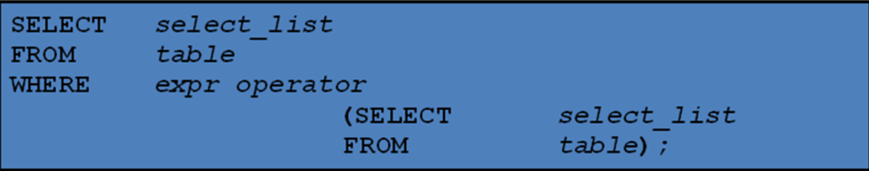

## **LAB TASKS:**

Create tables and insert data into it using the schema provided to you. Then perform the tasks below.

1. Write a query to display all the orders from the orders table issued by the salesman 'Paul Adam'.
2. Write a query to display only those customers whose grade are, in fact, higher than every customer in New York.
3. Write a query to display all the orders which values are greater than the average order value for 10th October 2012.
4. Write a query to count the customers with grades above New York's average.
5. Write a query to find the sums of the amounts from the orders table, grouped by date, eliminating all those dates where the sum was not at least 1000.00 above the maximum order amount for that date.
6. Write a query that extracts the rows of all salesmen who have customers with more than one order.

Write a query to get all the information for those customers whose grade is not as the grade of customer who belongs to the city London.